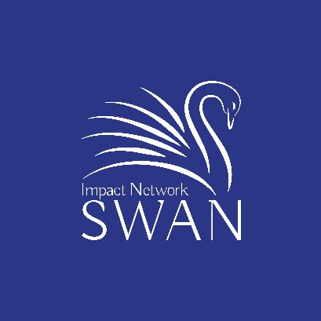
Associate Member
Application Form

The benefits of being an Associate include:

Associates have the opportunity to learn about a wide variety of young social-impact start-up companies located in Austin and in the rest of the country.

Associates get to meet and build relationships with impact start-ups, and Austin impact investors and Associates.

Associates get to learn about early-stage companies and early-stage investing.

Associate activities include:

Assisting in the down-selection process that identifies the companies that will present at the quarterly pitch events.

Attending and participating in the quarterly pitch events

Assisting in due diligence for companies late in the funding evaluation process

Optionally coaching companies in your area of expertise

The Requirements:
- Participation: There is no cost to become an Associate. Rather, your contribution to the network is providing the following services in kind:
  - participate in a majority of the “Step Two” Zoom down selection calls for In at least one quarterly funding cycle per year, and
  - help with a due diligence/deal memo activity In at least one quarterly funding cycle per year
- Conflict of Interests: If I have any sort of financial connection with a company that has applied for funding, I agree to recuse myself from all discussions regarding that company during down-selection, dinner pitch events and due diligence. A mentoring role that does not have the potential for a personal financial benefit does not require a recusal.
- Not acting as an investor: I understand that private companies are not allowed to offer investment opportunities to the general public. I agree that my role as an Associate is limited to advising the network’s investors, and that the private companies I learn about as an Associate are not offering me an investment opportunity.
- Publicity: I agree to allow my photograph and a short biography to be added to the network’s web site.
- Renewals: In December of every year you will asked if you would like to remain an Associate and if are able to allocate time in the coming year to SWAN activities as describe in paragraph 1.
- Confidential information: The companies that apply are providing sensitive information about their companies without requiring a non-disclosure agreement That said, I will respect the fact that the company is sharing sensitive information, and agree to the following:
  - While working with the SWAN Impact Network on down-selection or a deal memo, I will share what I have learned as part of this effort only with individuals working on one of these projects.
  - I will not retain any written material shared by the company
  - After completing the down selection or deal memo work, I will not knowingly use residual knowledge that I retain in a way that is detrimental to the company
- Non-solicitation: I understand and recognize that the SWAN Impact Network meetings and communications are focused on investment pursuits and I agree to not solicit for business with a party that I come in contact with through the network. Those parties include Angels, potential angels, portfolio companies, company applicants and Associates. I may respond to unsolicited inquiries for information on my business and may thereafter engage in a professional relationship that may develop.

Survey

Impact Subject Matter Expert: Are you a subject matter expert in one of the following impact investing focus areas? If so, please indicate which impact areas.
- Affordable Housing
- Agtech
- Education
- Employment
- Environment/Clean tech
- Fintech
- Health/Wellness/Life Science
- Impact Assessment
- Social Inequality
- Urban and City Challenges
- Veteran issues
- Women’s challenges
- Other: ___________________________________

Summary of your overall experience: Please summarize your experience (in about 15 words), including any details related to being an Impact Subject Matter Expert.

Due Diligence Topics: For which of the following topics do you feel most comfortable in helping to evaluate a company? (check as many as apply)
- the social impact (magnitude of the impact, verification of the impact)
- the executive team (emotional intelligence, domain knowledge and experience)
- the product and technology (readiness, development platform, scalability, technical competitive advantages)
- the market opportunity and sales strategy (customer need verification, motivation of early adopters, market size, competitive challenges, sales challenges, go to market strategy, sales channels, sales infrastructure)
- the exit (evidence of appetite for acquisitions, how much dilution may occur)
- the investment deal terms (for example, for convertible debt or preferred stock)
- the corporate governance (board of director structure, capitalization table)
- the finances (reasonableness and completeness of expenses and income plan)

Impact Interests: Please identify impact areas that you are interested in:
- Clean Tech/Protecting the Environment
- Improving Physical and Mental Healthcare Outcomes
- Improving Educational Outcomes
- Equal Opportunity/Social Justice/Empowerment
- Other: ___________________________________________________________________
Computer Skills: Are you reasonably computer savvy and have experience hosting zoom meetings? _______

Your Information
Bio: Please provide a short bio that we can put on the SWAN website.

Name: ___________________________________________
Email _____________________________________________
Phone: ____________________________________________

LinkedIn profile (or attach resume) __________________________________

Address: _____________________________________

______________________________________

Application
I understand the Background Information and Requirements, have completed the Survey, and apply to be an Associate.

Signature: _______________________________________________________

Date: _________________________________________

