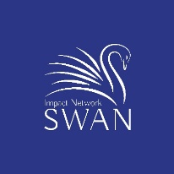
SWAN Subject Matter Expert Agreement

Working Relationship with SWAN: SWAN may periodically ask me to provide feedback on a company whose technology or market focus matches my area of expertise. SWAN agrees that I may decline any specific request for feedback.
Conflict of Interest: If I have any sort of financial connection with a company for which SWAN is asking for feedback, I agree to recuse myself from providing feedback.
Confidential information: SWAN agrees to share with me only information which is not covered by a non-disclosure agreement between the company and SWAN.
I agree to not retain any written material shared by SWAN on the company unless I receive permission from the company to do so.
I agree to not knowingly use residual knowledge about the company that I have learned through this activity in a way that is detrimental to the company.

Subject Matter Expert: Please indicate your area of expertise and provide a short summary of your expertise:
- Affordable Housing
- Agtech
- Education
- Education
- Employment
- Environment/Clean tech
- Fintech
- Health/Wellness/Life Science
- Impact Assessment
- Non Profits
- Social Inequality
- Urban Challenges
- Veteran issues
- Women’s challenges

Subject Matter Expertise Summary:

Name: ___________________________________________
Signature: __________________________________________
Date: _________________________________________
Email: _________________________________________

Phone number: ______________________________________

