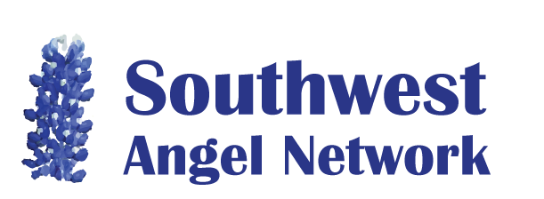
Application Form

To apply to the Southwest Angel Network, please submit a succinct document (emailed to bob.bridge@swanimpact.org) that answers each of the following questions:

- Company Basics:
  - company name
  - date of start of operation
  - type of legal entity (e.g., LLC, C-Corp)
  - headquarters location
  - web site
  - indication for-profit status (e.g.,“we are a for-profit company”)
- CEO:
  - Name
  - Email
  - Phone number
  - LinkedIn URL, or URL of personal website
  - Number of years of experience in all work positions
  - Number of years of experience as a start-up entrepreneur
- Business Summary:
  - Social impact hypothesis: “The company will make the world a better place by ” ………”.
    - Don’t confuse the benefits provided the payer and the benefits provided beneficiaries
    - What evidence exists that societal benefits actually occur?
    - How are the societal benefits measured?
  - Business hypothesis: “The company will become profitable by collecting revenue from ”<type of customers>“ to solve the following problem that the customer has ” …………”
- Product/Service offering: Summary of your product or service, including a short summary of the major business operational activities
- Financial:
  - In what month does your fiscal year end?
  - In the current fiscal year, what is the year-to-date revenue?
  - Indicate current burn rate and fume date.
  - Provide a copy of the accompanying financial summary spreadsheet.
- Market validation: If you don’t yet have revenue, briefly describe how you have validated your future revenue stream. For example, how many potential customers have you talked to about their problems? (See the web site for validation guidelines.).
- Competitive Advantage: What is your long-term sustainable competitive advantage? Is there any IP?
- Fund Raising:
Dollars raised in previous rounds
Total dollars being raised in current raise
Committed dollars in current raise
Anticipated dollars needed in future rounds to get to profitability
For current raise:
  - Type of raise (e.g., equity, convertible debt, royalty based financing, SAFE)
  - For equity, identify pre-money valuation
  - For debt, identify valuation cap, discount rate, and interest rate
  - What business result (i.e., business inflection point or business de-risking) will the investors buy with this investment?
  - Do you have a lead for the current financing round? If so please attach the term sheet.

