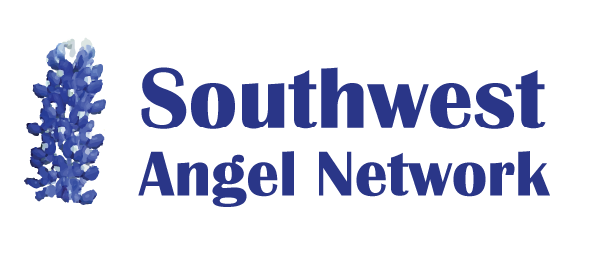

Membership Survey

The Southwest Angel Network is keenly interested in providing members with maximum benefit, which is aligned with member interests. One of the few ways we have to better understand these interests is to conduct membership surveys. Individual data will be used for internal purposes only and will not be shared externally
- What is your greatest strength in terms of work experience (by industry, or market, or technology, or functional area)?
_______________________________________________________________________
_______________________________________________________________________
- For which of the following topics do you feel most comfortable in helping to evaluate a company? (check as many as apply)
- the social impact (magnitude of the impact, verification of the impact)
- the executive team (emotional intelligence, domain knowledge and experience)
- the product (readiness, development platform, scalability)
- the market (customer need verification, motivation of early adopters, market size)
- the sales plan (sales challenges, go to market strategy, sales channels, sales infrastructure)
- the competition (direct and indirect competition, sustainable long-term advantage)
- the exit (evidence of appetite for acquisitions, how much dilution may occur)
- the investment deal terms (for example, for convertible debt or preferred stock)
- the finances (reasonableness and completeness of expenses and income plan)
- Other…__________________________________________________________
- Name: ___________________________________________
Thank you for completing this survey

